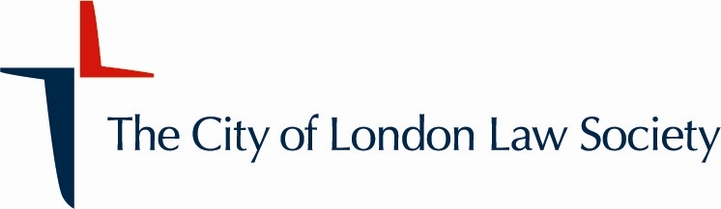

Environmental, Social and Governance (ESG)
Committee – Vacancies

The City of London Law Society (“CLLS”) ESG Committee is made up of solicitors and ESG experts whose work comprises law and practice governing the solicitors’ profession and their clients within the wider environmental, social, and governance remit. It also includes developing corporate social responsibilities of solicitors in the City of London and across the wider profession. The Committee wishes to recruit new members in response to its current workload and activities.

Applicants should be members (including affiliates) of the CLLS either individually or as part of a CLLS Corporate Member firm. While applicants can be partners or equivalent, we encourage other professionals and experts in ESG and law within our membership to consider applying. Applicants should be enthusiastic about the opportunity to contribute to the work of the Committee and of the wider CLLS, and be able to commit enough time to participate in its work, including regular in-person meetings in the City of London.

To apply, please contact the Committee Chair, Roger Leese, of Clifford Chance LLP, by e-mail at roger.leese@cliffordchance.com. The deadline for applications is close of business on Friday 4th April 2025.

When applying, please send a short CV and give an indication of your main areas of interest in the work of the Committee and what you would expect to contribute to the Committee. If you have any queries, please contact either Roger, or Kevin Hart at kevin.hart@clls.org.

The CLLS is committed to the principles of equality, diversity and inclusion, and welcomes applications from all members of the profession irrespective of age, disability, gender, race, religion or sexual orientation.

The City of London Law Society
www.citysolicitors.org.uk

********************************************************

